**Assignment-6**

**1.Write a query to display the name (first name and last name) for those employees**

**who get more salary than the employee whose ID is 163?**

select first_name,last_name,salary from employees

where salary>(select salary from employees where employee_id=163);

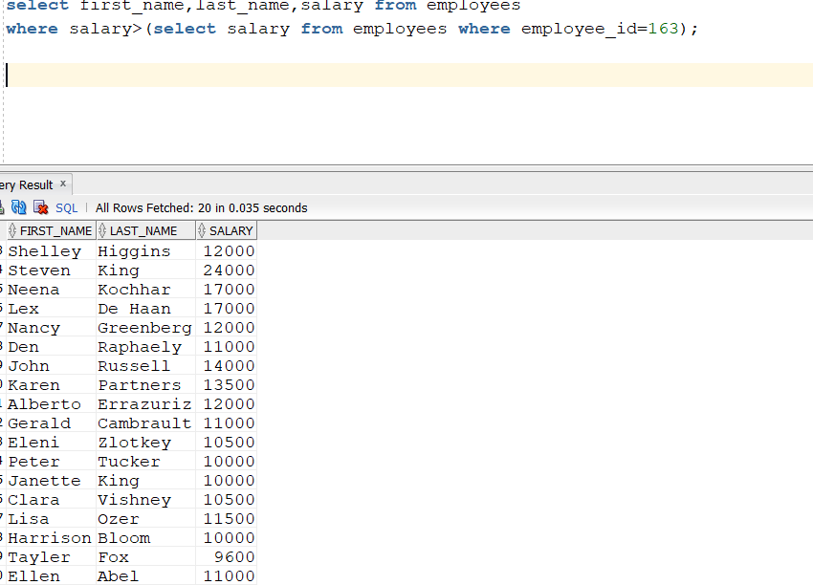

**2.Write a query to display the name (first name and last name), salary, department id**

**for those employees who earn such an amount of salary which is the smallest salary of any of the departments**.

select first_name,last_name,salary,department_id from employees

where salary in(select min(salary)from employees group by department_id);

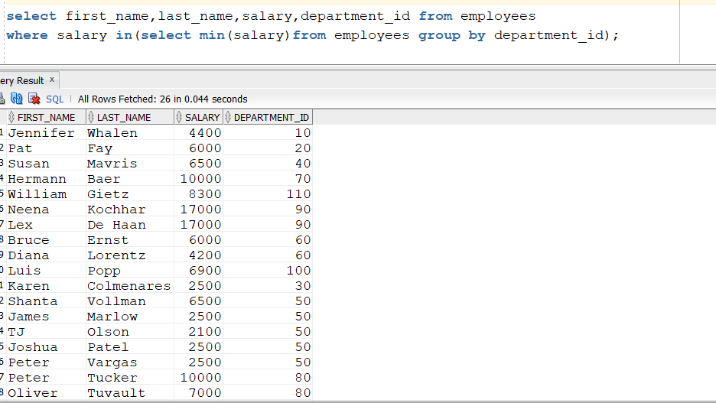

**3. .Write a query to display the department number, name (first name and last name), job_id and department name for all employees in the Finance department?**

select e1.first_name,e1.last_name,e1.job_id,d1.department_name

from employees e1,departments d1

where e1.department_id=d1.department_id

and d1.department_name='Finance';

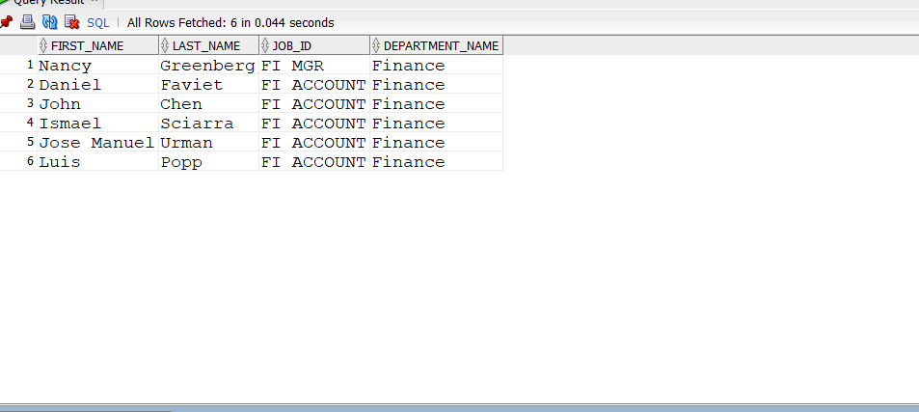

**4. Write a query to display all the information for those employees whose id is any id who earn the second highest salary?**

select employee_id,max(salary) from employees

where salary<(select max(salary) from employees)

and rownum<=1

group by employee_id

(or)

select employee_id,max(salary) from employees

where salary<(select max(salary) from employees)

and rownum<&n

group by employee_id

(or)

select employee_id,salary,rank() over(order by salary desc)rank from employees

where rank=2

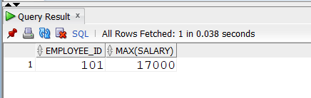

**5.Write a query to display the employee number, name (first name and last name),**

**and salary for all employees who earn more than the average salary and who work in a department with any employee with a J in their name.**

select employee_id,first_name,salary from employees

where salary>(select avg(salary) from employees)

and first_name like'%J%' order by salary

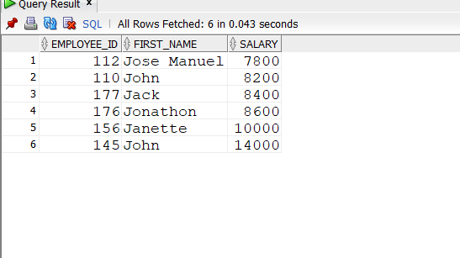

**6.Write a query to display the employee number, name (first name and last name) and job title for all employees whose salary is smaller than any salary of those employees whose job title is MK_MAN?**

select employee_id,concat(concat(first_name,' '),last_name)Name,job_id,salary from employees

where salary<(select salary from employees where job_id='MK_MAN')order by salary desc

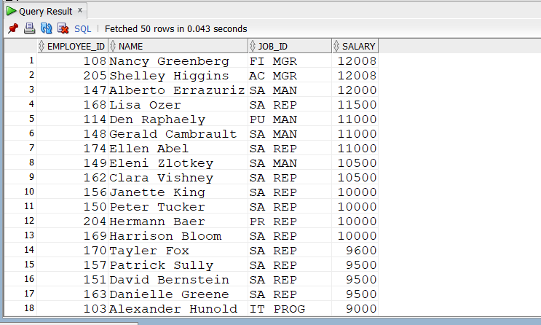

**7.Write a query to display the employee name( first name and last name ) and department**

**for all employees for any existence of those employees whose salary is more than 3700?**

select first_name,last_name,department_id,salary from employees

where salary>3700

order by salary

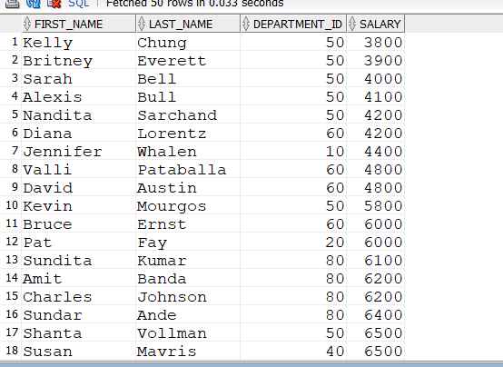

**8**.**Write a query that will identify all employees who work in departments located in the United Kingdom?**

select concat(first_name,last_name)name,e.department_id,e.salary,l.country_id from employees e

inner join departments d

on e.department_id=d.department_id

inner join locations l

on d.location_id=l.location_id

where country_id ='UK'

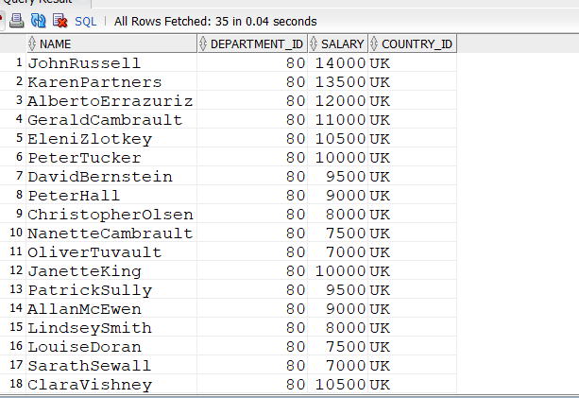

**9.Write a query to get the details of employees who manage a department?**

select * from employees where employee_id=any(select manager_id from departments );

(or)

select * from employees where employee_id in(select manager_id from departments );

(or)

select e.employee_id,job_id,d.department_name from employees e

inner join departments d

on e.department_id=d.department_id

where e.employee_id in(select manager_id from employees)

order by employee_id

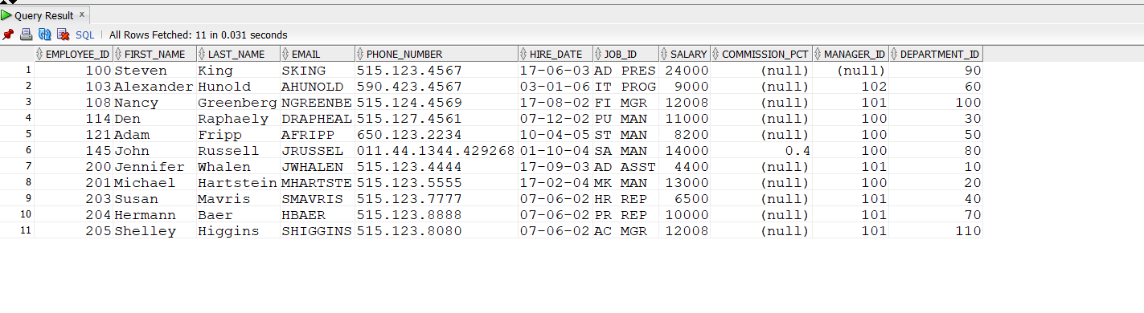

**10.Write a query to display the employee id, name (first name and last name), salary, department name and city for all the employees**

**who get the salary as the salary earned by the employee**

**which is maximum within the joining person January 1st, 2002 and December 31st, 2003?**

select concat(first_name,last_name)Name,e.salary,e.hire_date,d.department_name,l.city

from employees e

inner join departments d

on e.department_id=d.department_id

inner join locations l

on d.location_id=l.location_id

where e.salary=(select max(salary)from employees

where hire_date between '01/01/2002' AND '12/12/2003')

